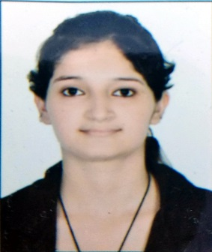
RESUME

Personal Details

- Name: Komal Chawla
- Mobile: 9149162329, 7055523662
- Email ID: chawlakomal202@gmail.com
- Date of Birth : 14 July 1996
- Father’s Name: Ajay kumar Chawla
- Nationality : Indian
- Marital Status : Unmarried
- Languages Known: English and Hindi
- Address : Flat F-12 Purushottam Bagh, Dayalbagh , Agra(U.P.)

Personal Statement

To be a part of an organization with scope of a challenging career opportunity for learning with continuous improvement of skills, experience and knowledge with the wide scope of growth.

Skills Summary

- Data management. _Employee Engagement. _ Attendence Management
- Recruitment. _Joining and Induction. _Screening.

Computer Skills

Basic Knowledge in computer
MS office.

Relevant Skills

- Wages and salary Administration.
- Statutory compliances ( PF,ESI, Gratuity & Bonus ).
- Statutory deductions ( PF,ESI ).
- Generating pay slips.
- Knowledge of Recruitment.

Personal Skills

- Supportive in nature.
- Communication Skill.
- Strong willingness to learn new skills and ability.
- Hard work and Team work.
- Patience
- Time management
- Truthful
- Honest

Education Qualification

- M.B.A in Human resource and finance from Dr. A.P.J Abdul Kalam Technical University in 2020 .
- Completed Graduation ( B.com) from B.R Ambedkar University in 2017.
- Intermediate from C.B.S.E Board in 2014.
- High school from C.B.S.E Board in 2012.

Working Experience

Internship in HR

- I have done 45 days of HR internship in Basant Overseas LTD.

Training Attended

- HR Generalist training program from Alliance Training and Skill Development, Agra.

Topics
- Wages and salary Administration ( structuring).
- Payroll Management
- Statutory compliances ( PF,ESI, Gratuity and Bonus).
- Performance Appraisal.
- Performance Analysis.
- Training and development.
- Recruitment and selection Process.
- Industrial Laws such as ( Industrial dispute Act 1947, Factories Act 1948, Minimum wages Act 1948, Maternity Benefit Act 1961).
- Allowances ( DA,HRA, Travelling Allowance and Medical Allowance etc).

Declaration

I Hereby declare that the above – furnished details are true with Proven records.

Place: Agra

Date: ( Komal Chawla )

